0

** First event 26th September **

12:30pm – 2pm

Everyone welcome

Cost £3.50 for two course lunch & coffee

Friendship ⏺ Food ⏺ Fun

**Lunch Club**

At the village fete in June we challenged you to beat some of the official world records featured on: <http://challengers.guinnessworldrecords.com/>

Well done to the following North Bradley gold-medal performances – if you can do better let us know! :

**Challenge 1**: *Longest coin-spin with 10p coin*

10.81 seconds by Thomas

**Challenge 2**: *basketball circles around waist in 30 seconds*

40 by Laurence

**Challenge 3:** *quickest time to eat 3 cream crackers*

1 minute 39 seconds by Isaac

**world record challenges –** winners!

1a Westbury Road

North Bradley

BA14 0YN

www.nbbc.org.uk

Ben Midgley

Summer 2012

01225 768 566 pastor@nbbc.org.uk



…to this quarter’s News sheet,

Lots going on as usual, no room for post-Jubilee/Olympic blues!

We are putting our toe in the water for a Lunch Club and we’ll do a taster (excuse the pun), and if it goes well, we’ll run it again.

Roast beef dinner with pud and coffee, £3.50, and no washing up! Can’t be bad, but you have to pre-book as we need numbers, so call Marg on 769782 in good time to avoid disappointment.

Apart from that, God is still good, and general Church life too, and it would be great to see you getting involved if you haven’t already done so.

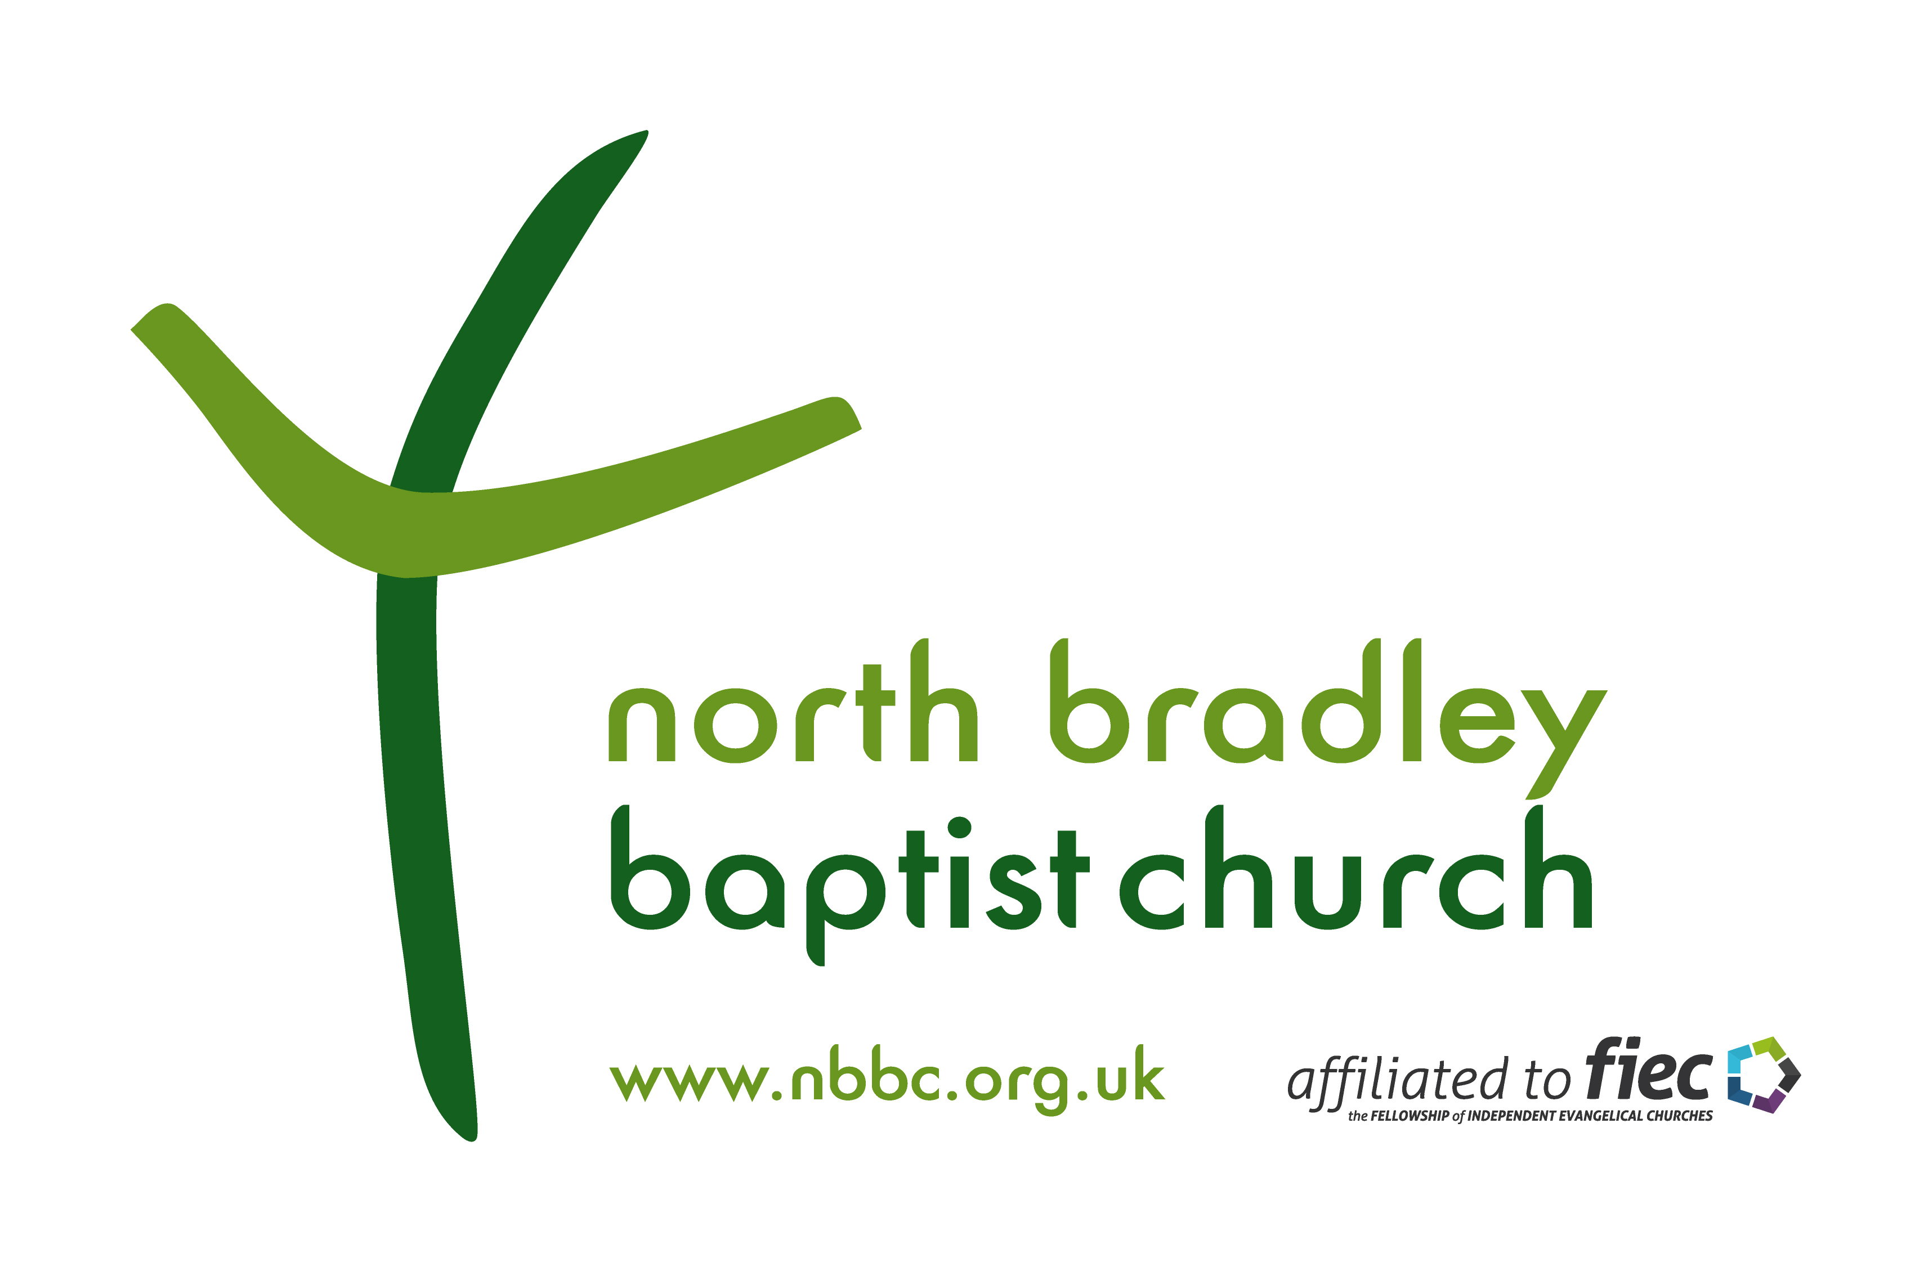

Inside:

Survey results

Baptisms

Youth clubs

New lunch club!

Summer 2012

LIFE

HOPE

FAITH

**😐**

£

?

Welcome . . .

**Regular Activities:**

Sun 10:45am Worship Service with Kids Church for 4-10

year olds and crèche facilities

Sun 6pm Evening Worship Service followed by

refreshments

Tues 7:30pm Prayer and bible study (apart from Home

Groups on the 2nd Tuesday of every month)

Wed 2:30pm Ladies Fellowship Meeting with visiting

speakers (Bi-Weekly)

Fri 6:30pm Signposts Club (primary school children)

Games, refreshments, and bible stories

Fri 7:30pm Toast Club (Ages 11-18)

Youth club with games, food and bible talk



**Please come along - we’d love to see you!**

